Customer Churn Analysis
Identifying Drivers of Customer Attrition and Revenue Loss

1. Executive Summary
Customer retention is a critical challenge for subscription-based businesses. Acquiring new customers is significantly more expensive than retaining existing ones. This project analyzes customer churn behavior using customer demographic, service usage, contract, payment, and billing information.
The objective is to identify the factors contributing to customer attrition, estimate revenue loss caused by churn, and provide actionable recommendations to improve customer retention.
Through Python-based exploratory data analysis, SQL business analysis, and Power BI dashboarding, key churn patterns were identified across contract types, payment methods, tenure groups, and customer support services.

2. Business Problem Statement
The telecom company is experiencing customer churn, resulting in reduced revenue and increased acquisition costs.
Key business questions:
- What is the overall churn rate?
- Which customer segments are most likely to churn?
- Which services influence churn?
- Which customer groups contribute most to revenue loss?
- What actions can reduce churn and improve retention?

3. Dataset Summary
The dataset contains customer information from a telecom company and is used to analyze customer churn behavior. Each record represents a unique customer and includes demographic details, subscription information, service usage patterns, billing details, and churn status.
Dataset Size :
- Total Records (Rows): 7,043
- Total Features (Columns): 21
- Target Variable: Churn (Yes/No)
Key Feature Categories :
- Customer Demographics – ( Customer ID, Gender, Senior Citizen Status, Partner Status, Dependents Status )
- Customer Account Information- (Tenure (Months with Company), Contract Type, Paperless Billing, Payment Method )
- Telecom Services – ( Phone Service, Multiple Lines, Internet Service, Online Security, Online Backup, Device Protection, Tech Support, Streaming TV, Streaming Movies )
- Billing Information - ( Monthly Charges, Total Charges )
- Target Variable - Churn (Customer Left or Stayed)
- Blank Spaces – Total 12 Blank Spaces in ( Totalcharges Column )

4. Exploratory Data Analysis using Python
We began with data preparation and cleaning in Python:
- Data Loading: Imported the dataset using pandas.
- Initial Exploration: Used df.info() to check structure, df.describe() for summary statistics and df.shape() to count all rows and columns
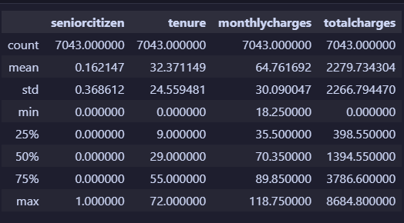
- Blank Spaces Handling: Checked for null values and blank spaces then I found blank spaces in the totalcharges column by using this function (df == " ").sum() and replace blank spaces with zeroes.
- Column Standardization: Renamed columns to snake case for better readability and documentation.
- Change Datatype : In dataset I found object datatype in Totalcharges Column then I changed datatype into float datatype using this function df['totalcharges'].astype(float)
- Change Value : In dataset I found value of Totalcharges Column is in
( 0 and 1 ) form so I changed it into ( Yes and No ) values using this method.

def func(value):
if value == 1:
return "Yes"
else:
return "No"
df['seniorcitizen'] = df['seniorcitizen'].apply(func)

- Database Integration: Connected Python script to MySQL and loaded the cleaned DataFrame into the database for SQL analysis.

5. Data Visualization using Matplotlib and Seaborn
Churn by Distribution : Total 1869 customers have churned and approximately 26.5% customers have churned.

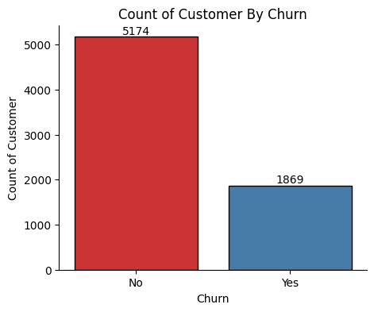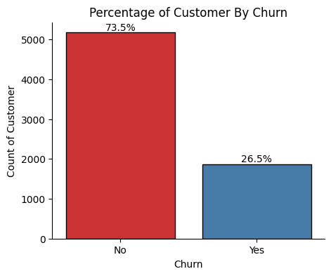

Churn by Contract Type :
- Month-to-Month customers exhibit the highest churn.
- Long-term contracts demonstrate stronger customer loyalty.
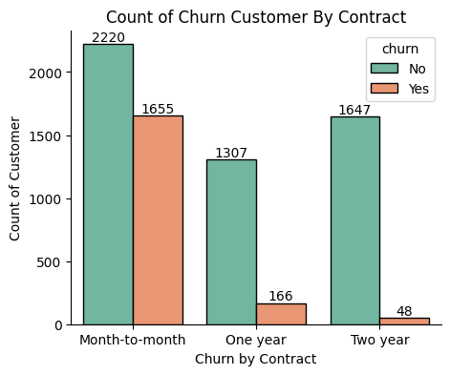

Churn by Gender : Total 939 female customers and 930 male customers have churned.
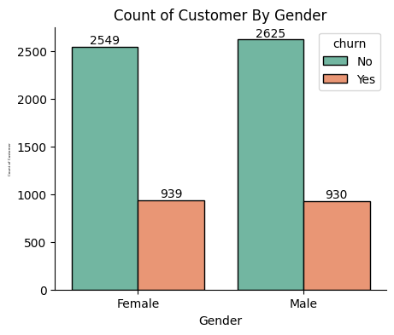
Churn by Senior Citizen : Total 476 senior citizen out of 666 senior citizen have churned.
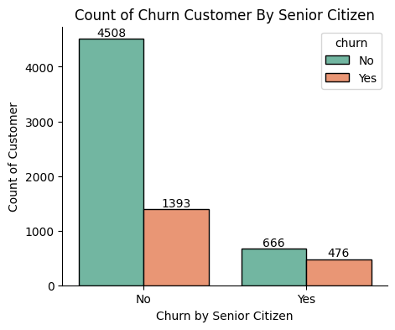
Churn by Tenure : Churn by tenure using histogram Chart
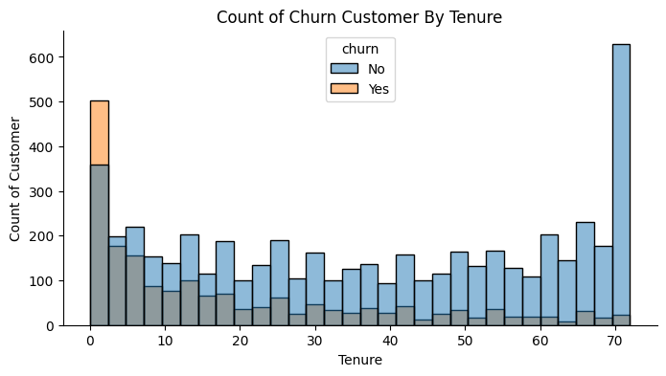
Churn by Payment Method
- Electronic Check customers display elevated churn rates.
- Payment experience may influence customer retention.
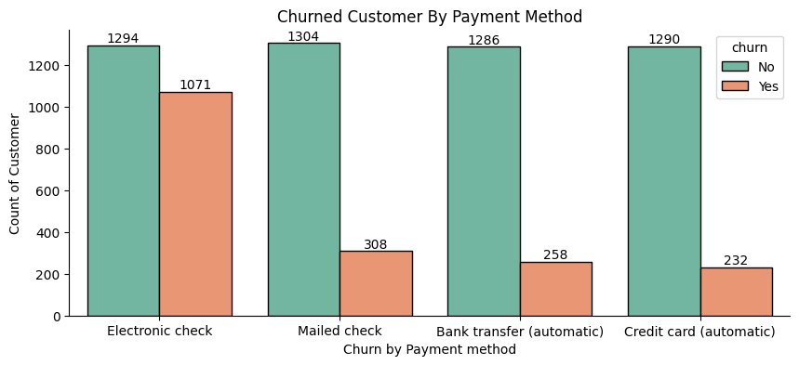

6. Business Analysis Using SQL
We performed structured analysis in MySQL to answer key business questions:
- What Is the Overall Customer Churn Rate?
The overall churn rate is 26.54%, indicating a significant portion of customers discontinue services.
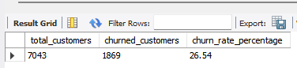

- Which Contract Type Has the Highest Churn?
Customers on Month-to-Month contracts show the highest churn rate. Long-term contracts demonstrate stronger customer retention and Encouraging customers to switch to longer contracts may reduce churn.
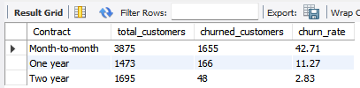

- Which Payment Method Has Highest Churn?
Customers using Electronic Check exhibit the highest churn rate.
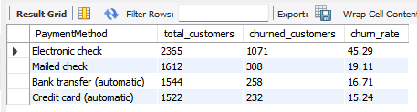
- Does Tenure Affect Churn?
Churned customers have a significantly lower average tenure than retained customers.
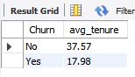

- Does Monthly Charge Affect Churn?
Churned customers pay higher average monthly charges compared to retained customers.
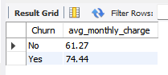

- Which Internet Service Has Highest Churn?
Fiber Optic customers have the highest churn rate among service categories.
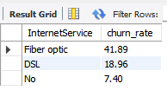
- Does Tech Support Reduce Churn?
Customers without technical support are significantly more likely to churn. Promoting Tech Support packages could reduce future churn.
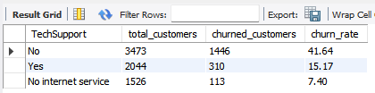

- Which Customer Segment Causes Highest Revenue Loss?
The highest revenue loss originates from customers in the Monthly contract segment.
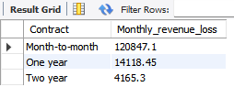

- Are Senior Citizens More Likely to Churn?
Senior Citizens exhibit a churn rate of 41.6%, compared to 23.6% for non-senior customers. This group may require more personalized support and engagement.
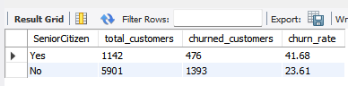

- Which Customer Groups Should the Company Target First for Retention?
The identified customer segment experiences the highest churn while contributing meaningful revenue
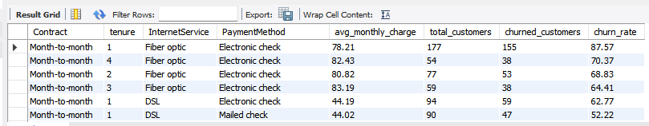
- Which Combination of Features Creates Highest Churn Risk?
Customers with the combination of Monthly Contract, Fibre optic Internet Service, and Electronic Payment Method show the highest churn risk.
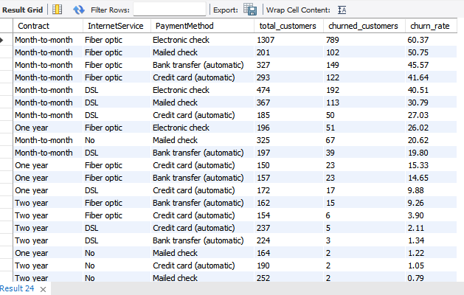

- What Is Total Revenue Lost Due to Churn?
Total revenue lost due to churn is ₹2862926.9
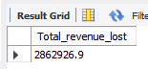

7. Key Business Findings
- Month-to-Month customers have the highest churn rate.
- Customers without Tech Support are significantly more likely to churn.
- Electronic Check users demonstrate higher churn risk.
- Customers with shorter tenure show increased churn probability.
- Senior Citizens churn at a higher rate than non-senior customers.
- Fiber Optic customers exhibit elevated churn levels.
- High monthly charges correlate with increased churn.
- The majority of revenue loss originates from specific high-risk customer segments.

9. Power BI Dashboard
Provide executives with an interactive view of churn trends, revenue loss, and customer risk factors.
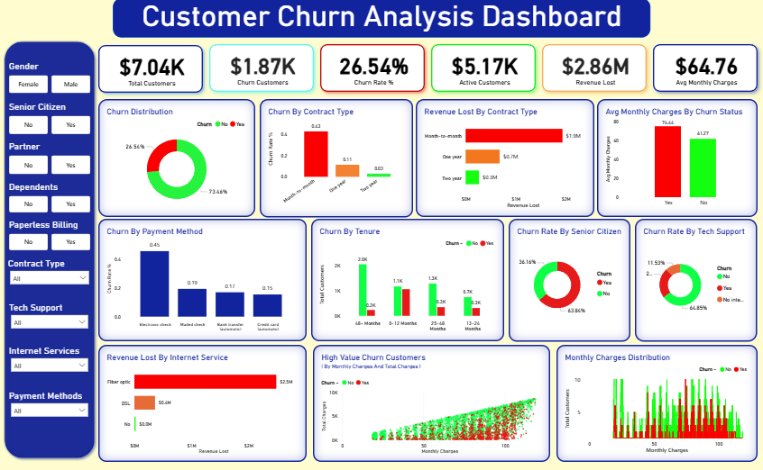
9. Business Recommendations
- Promote annual and two-year contracts through discounts and loyalty benefits.
- Offer proactive retention campaigns to customers with low tenure.
- Provide bundled Tech Support packages.
- Investigate churn among Fiber Optic customers.
- Implement targeted outreach for high-value customers at risk of churn.
- Improve payment experience for Electronic Check users.
10. Conclusion
This project successfully identified the major factors influencing customer churn through Python-based exploratory analysis, SQL-driven business analysis, and Power BI dashboarding.
The analysis revealed that contract type, tenure, internet service, payment method, and technical support availability are the primary drivers of customer attrition. By implementing targeted retention strategies based on these findings, the company can reduce churn, preserve revenue, and improve long-term customer loyalty.

